Simplified Preflop Charts – Bayesian Poker

** READ BEFORE USING **

Word Settings
This document is a collection of simplified GTO preflop charts for 6-max NLHE cash games, with action frequencies rounded to the nearest 25%.
To get the most from this document, make the following two changes to your Microsoft Word settings if needed:
First, set the layout to Web Layout so the charts display without page breaks.
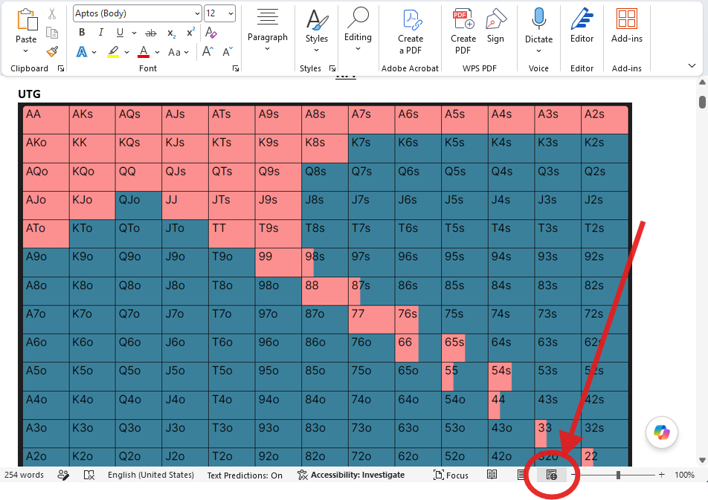
Second, use the search bar to find and activate the navigation pane. It should appear on the left with expandable labels, which you can click to jump to any chart in the file.
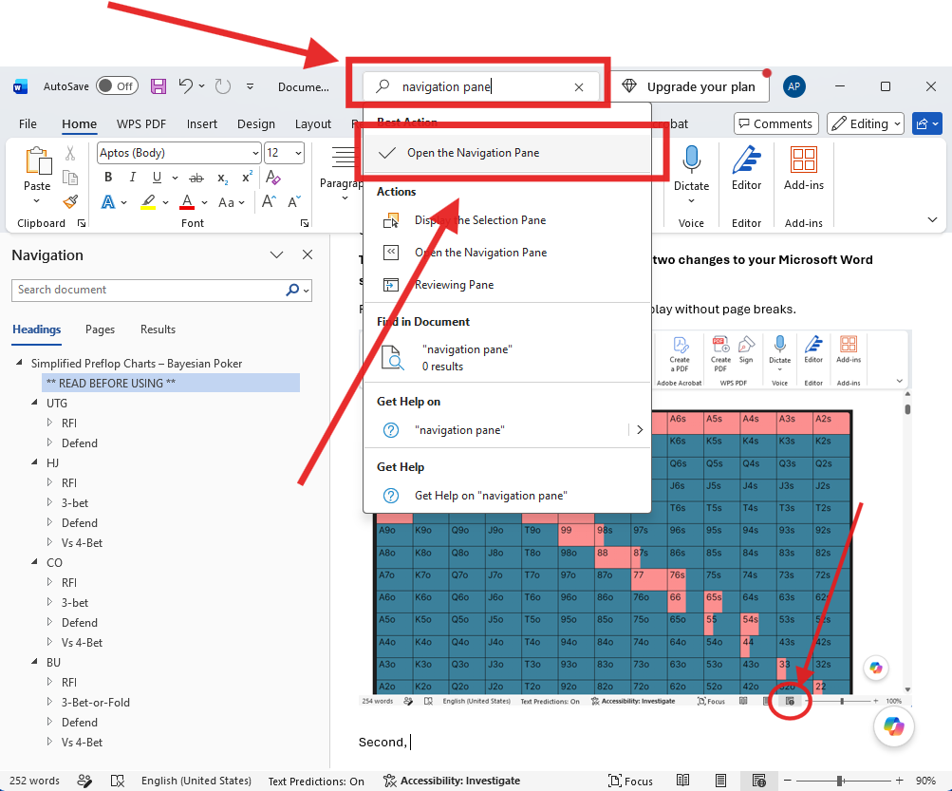

How the Charts are Organized
- The charts are primarily organized by position. Every chart you’ll need for the Hijack is under the large heading HJ, for example.
- From there, the navigation pane expands to reveal every heads-up preflop node.
  - RFI is HJ’s opening range
  - 3-bet is his strategy facing an open from the position indicated
  - Defend is his strategy after opening, getting 3-bet by the position indicated, and having the action fold back to him
  - Vs 4-bet is his strategy vs a 4-bet after you 3-bet the position indicated
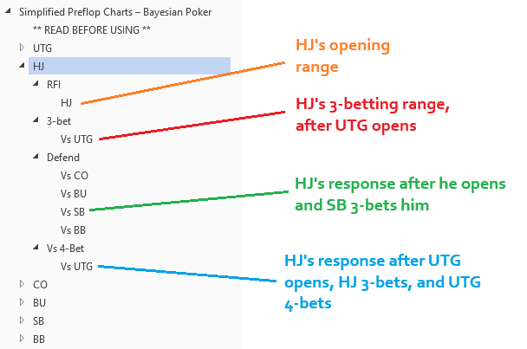
So, for example, the range indicated by the green (HJ Defend Vs SB) is the range you should use after the action folded to you in the HJ, you open raised, then the action folded to the SB who 3-bet, and the action folded back to you.

Sizing
Here are the raise sizes used in the raw sim.
- RFI to 2.5BB from all positions except SB, which RFIs to 3BB.
- Facing a 2.5BB open, 3bet to 7.5BB as IP, 10BB as the SB, and 11BB as the BB.
  - Facing a 3BB open from the SB, BB 3-bets to 9BB.
- Facing a 7.5BB 3-bet, 4-bet to 20BB.
- Facing a 10BB 3-bet, 4-bet to 22.
- Facing an 11BB 3-bet, 4-bet to 23.
  - Facing a 9BB 3-bet from the BB, 4-bet to 22.5BB as SB

One final note
In addition to rounding frequencies to the nearest 25%, some attention was paid to overall balance. If, for example, a 4-bet bluffing range consisted of several hands that raise 5% of the time, rounding all of these to 0% would result in an underbluff. In these cases, the charts compensate by arbitrarily selecting one combo to 4-bet 25% of the time, while rounding the rest to zero.
Good luck and enjoy the charts!

UTG

RFI

UTG
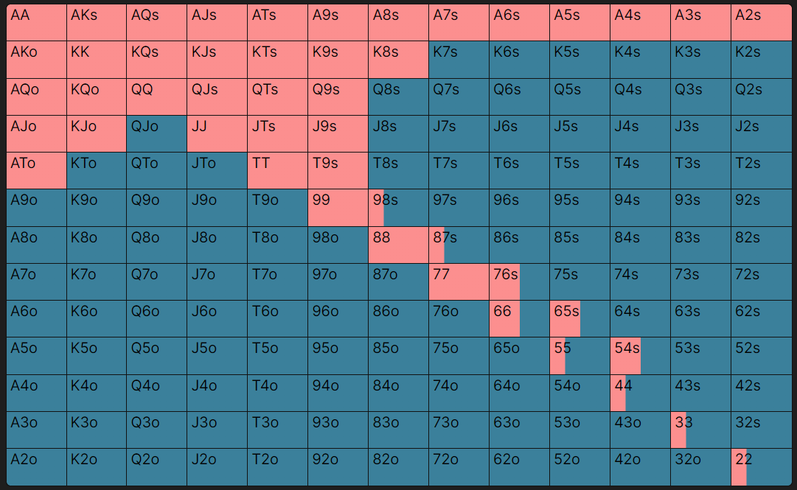

Defend

Vs HJ
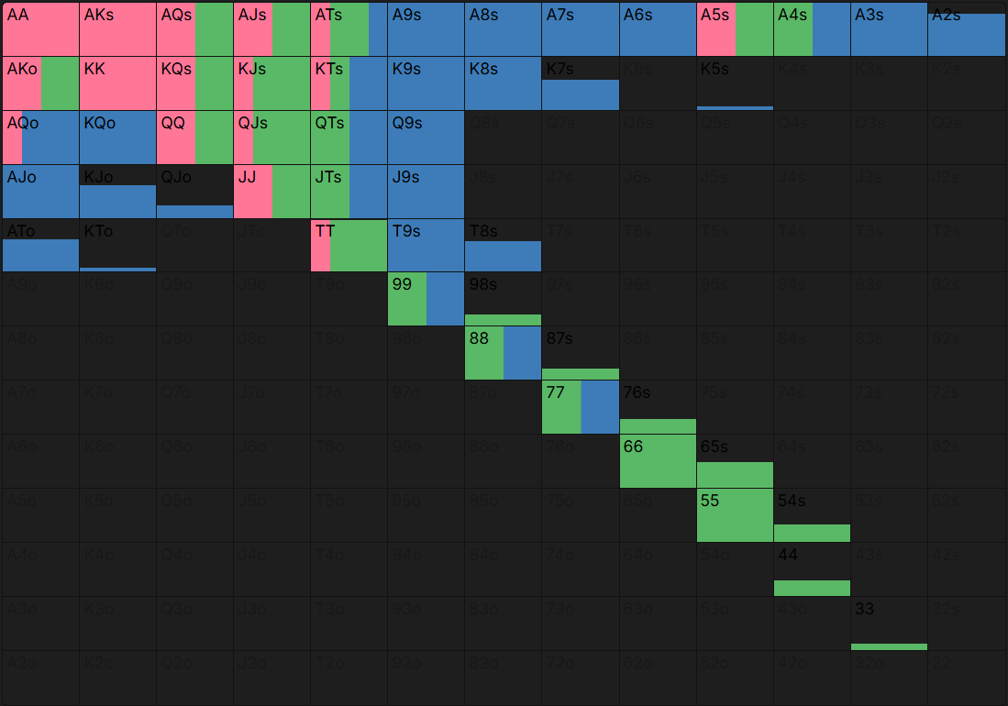

Vs CO
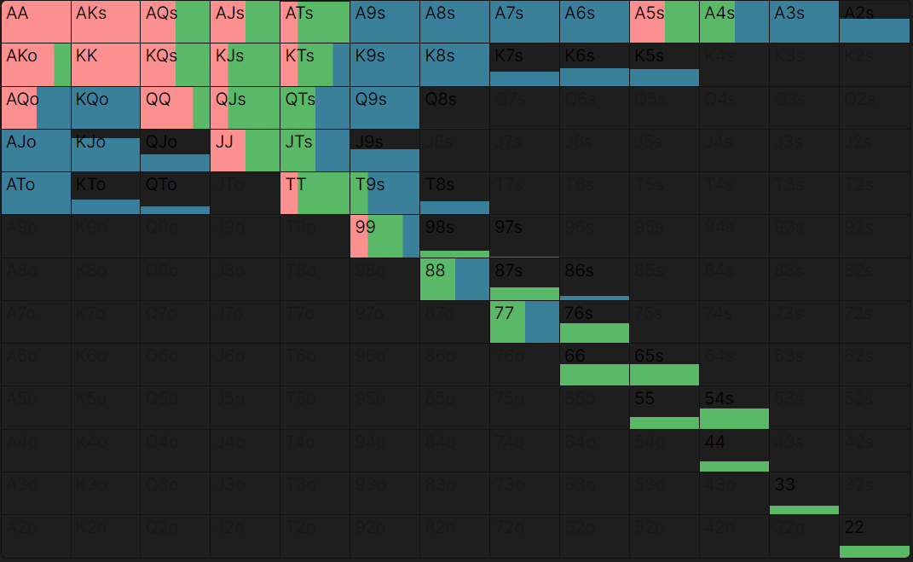

Vs BU
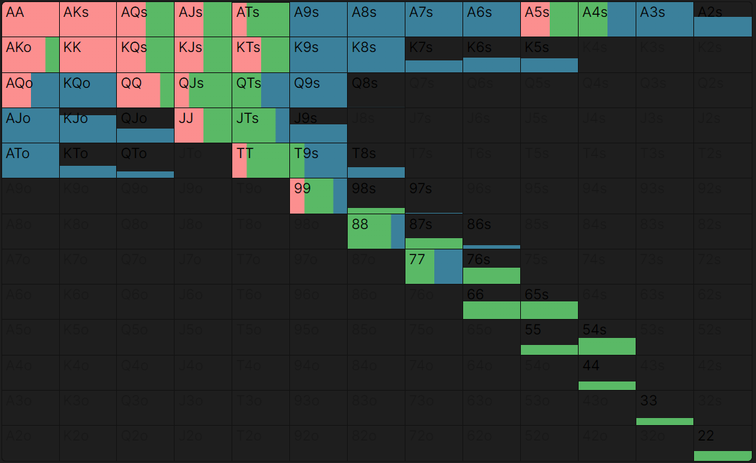

Vs SB
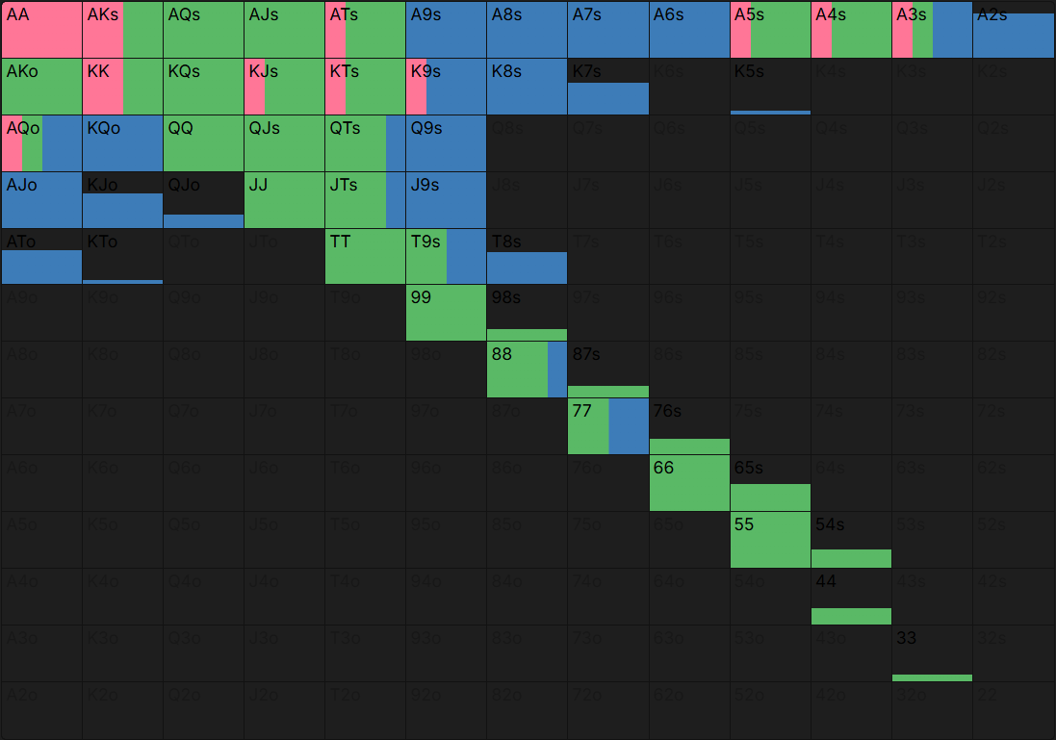

Vs BB
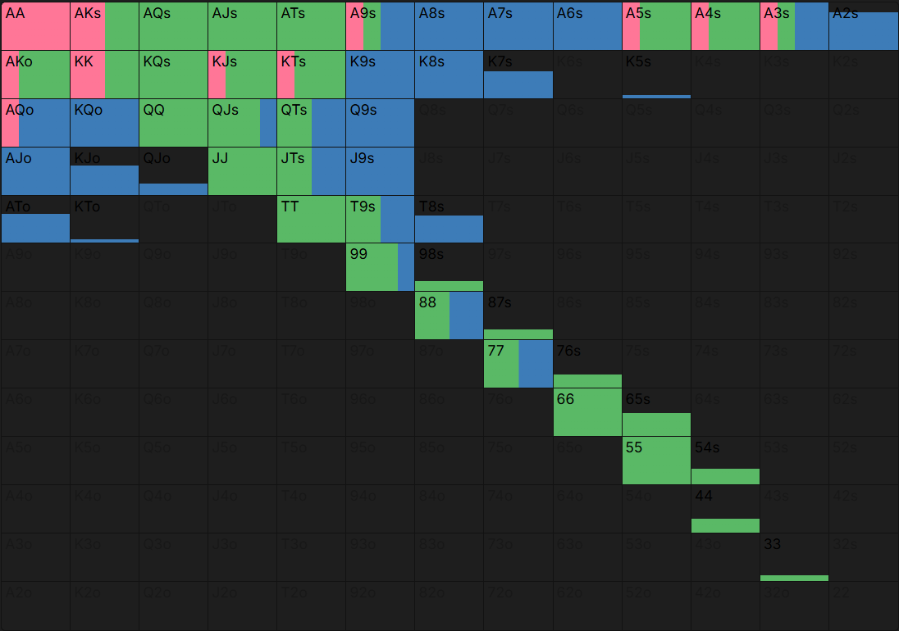

HJ

RFI

HJ
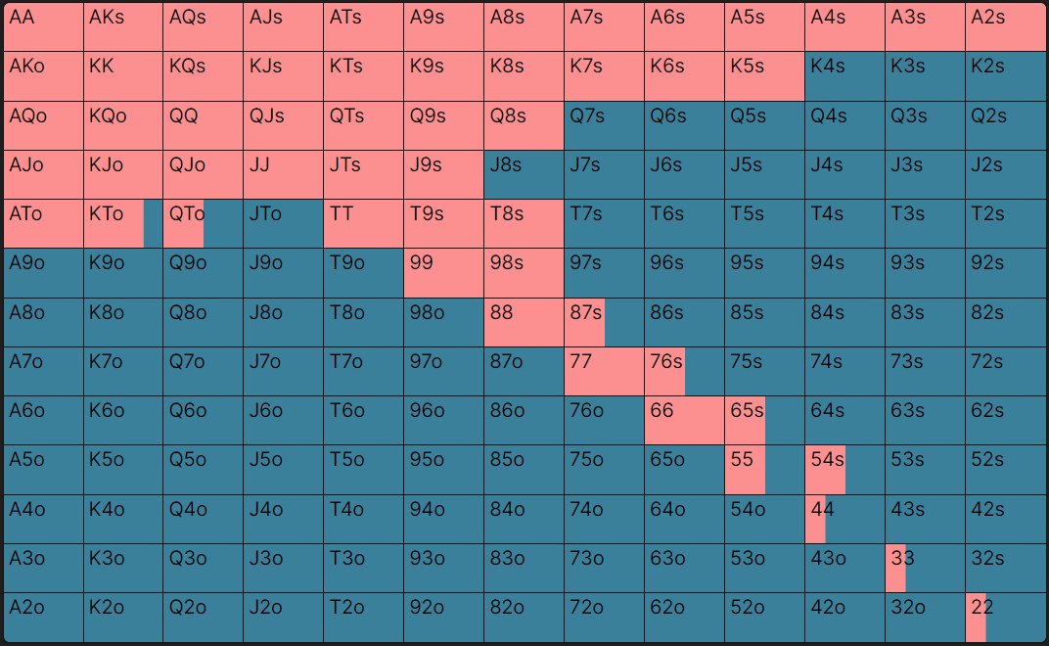

3-bet

Vs UTG
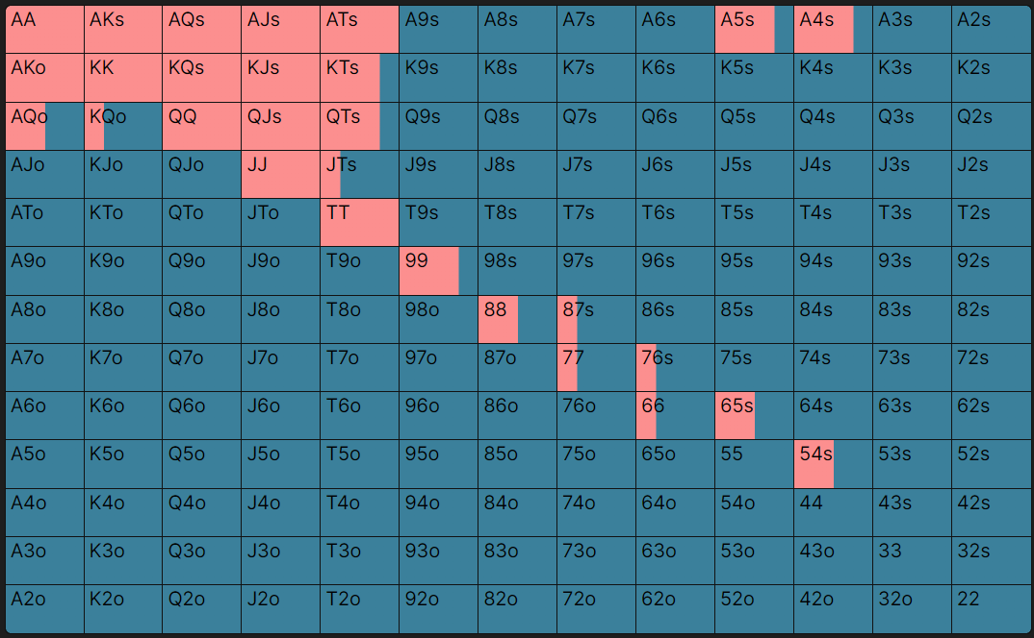

Defend

Vs CO
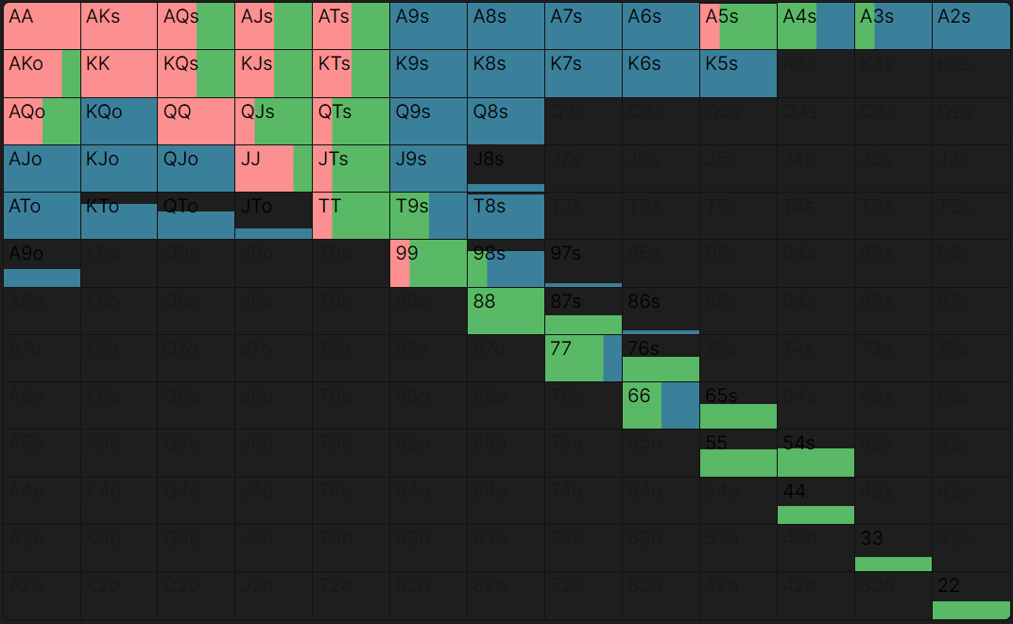

Vs BU
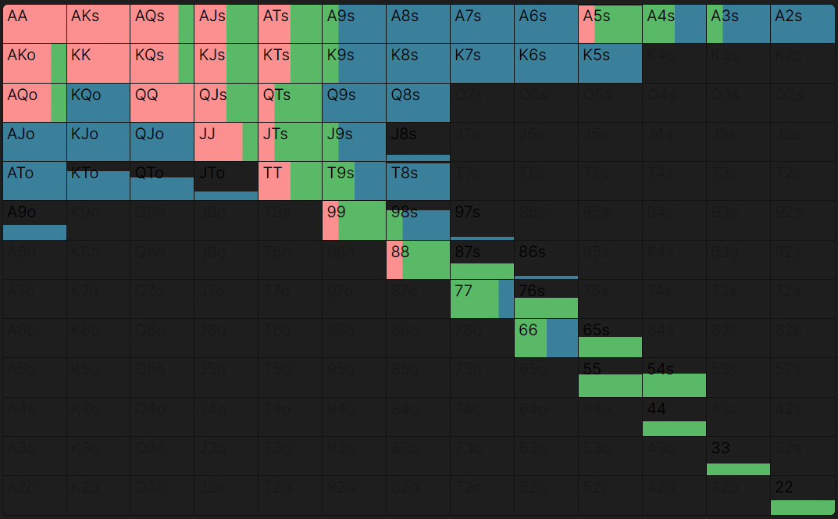

Vs SB
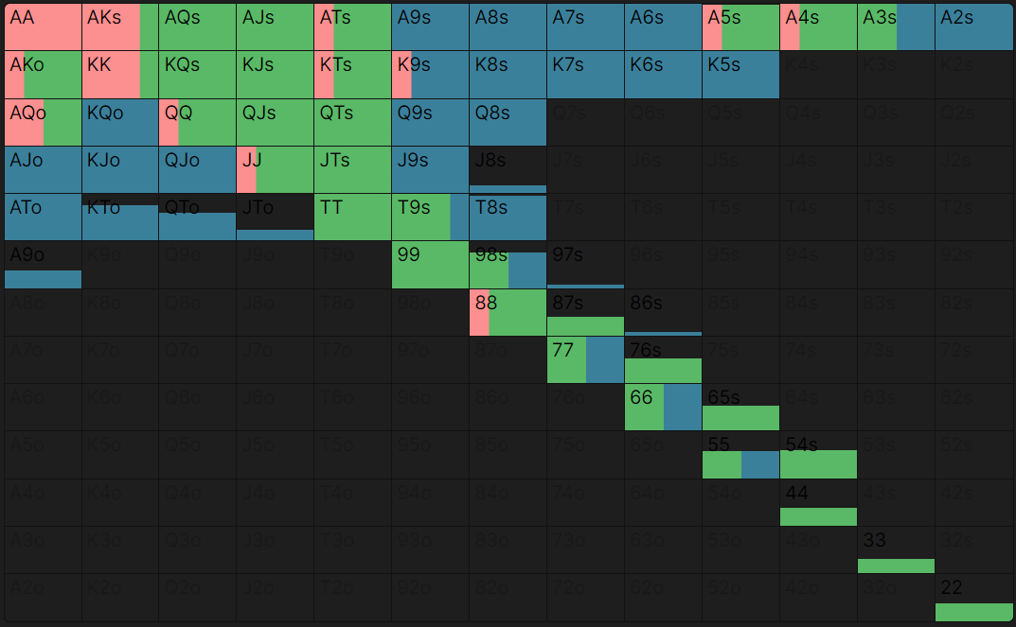

Vs BB
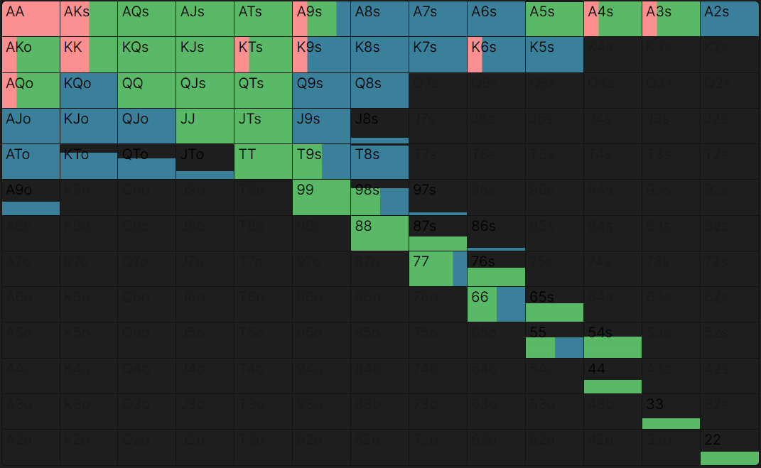

Vs 4-Bet

Vs UTG
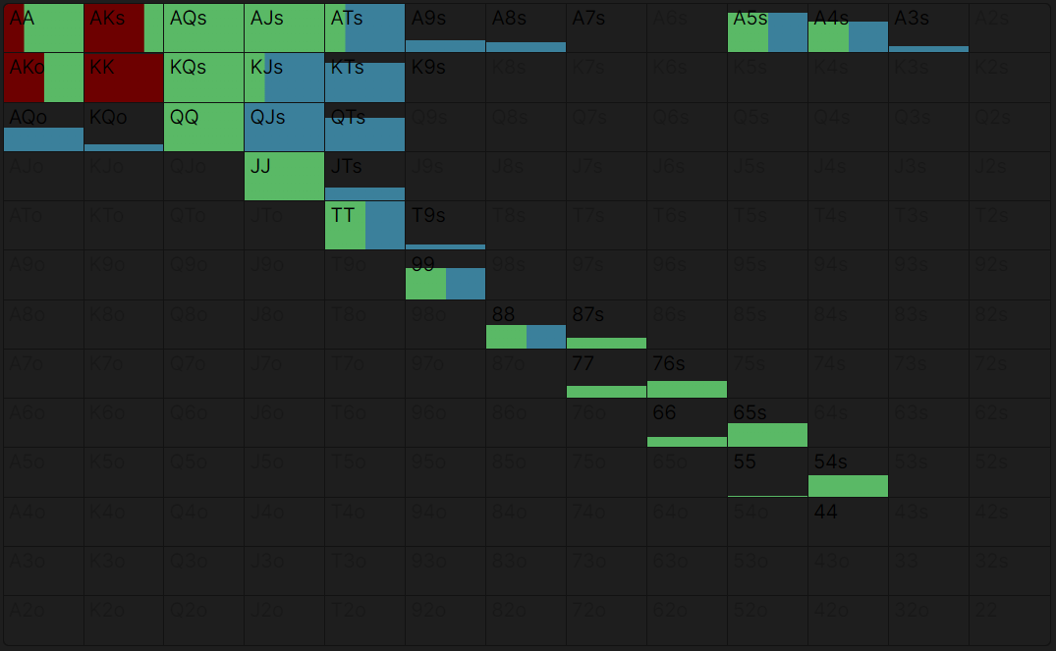

CO

RFI

CO
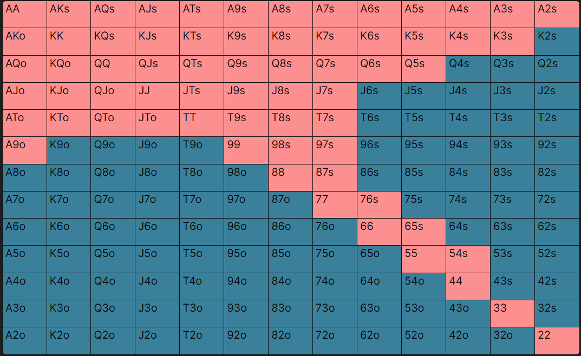

3-bet

Vs UTG
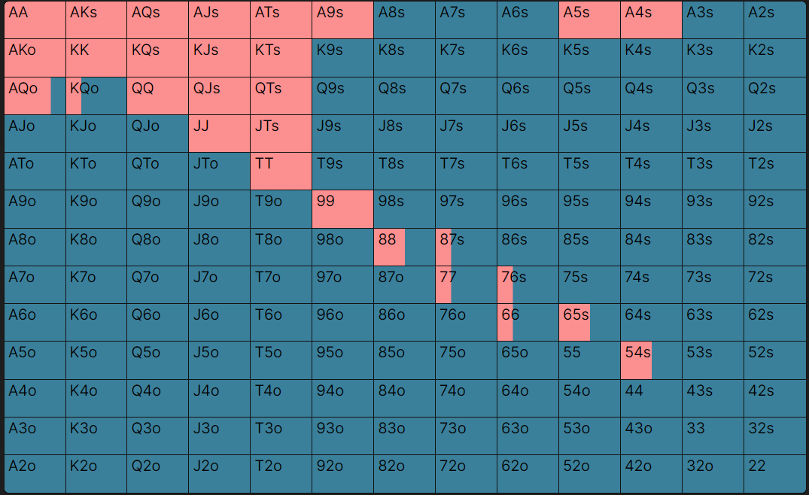

Vs HJ
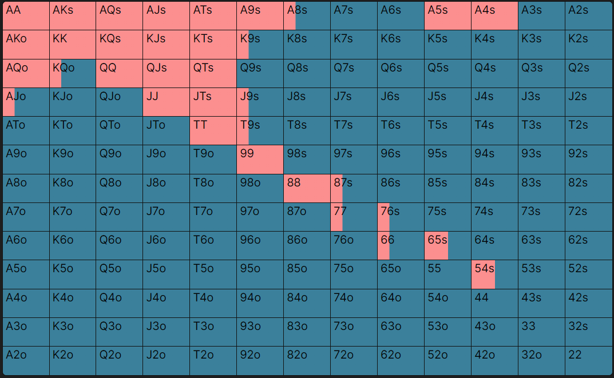

Defend

Vs BU
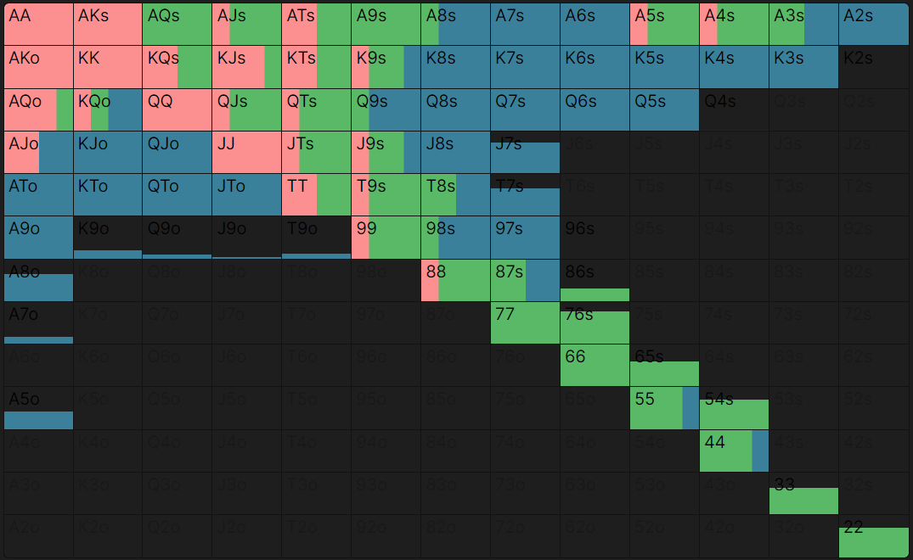

Vs SB
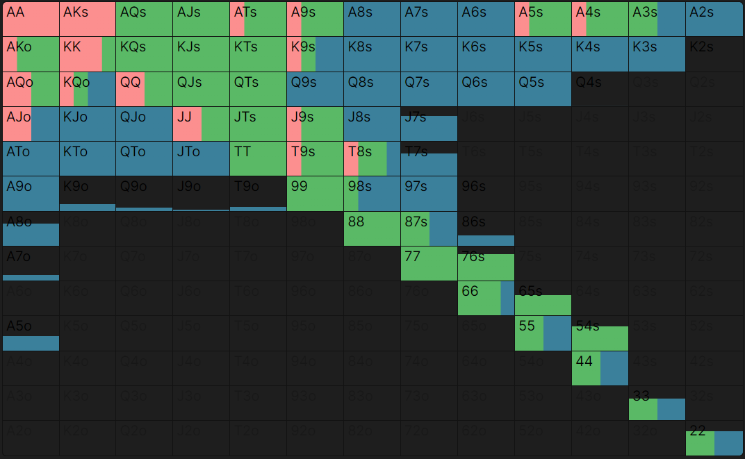

Vs BB
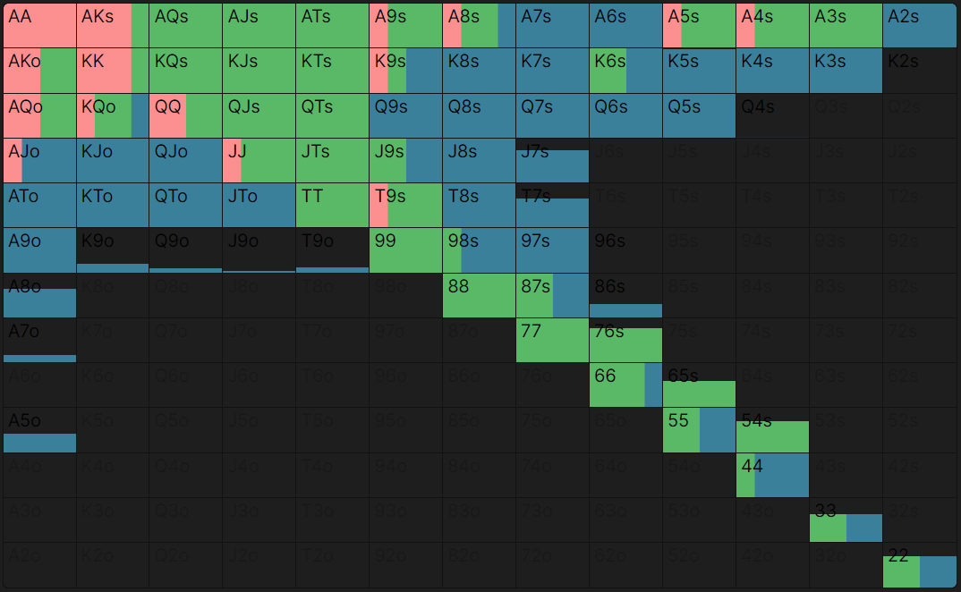

Vs 4-Bet

Vs UTG
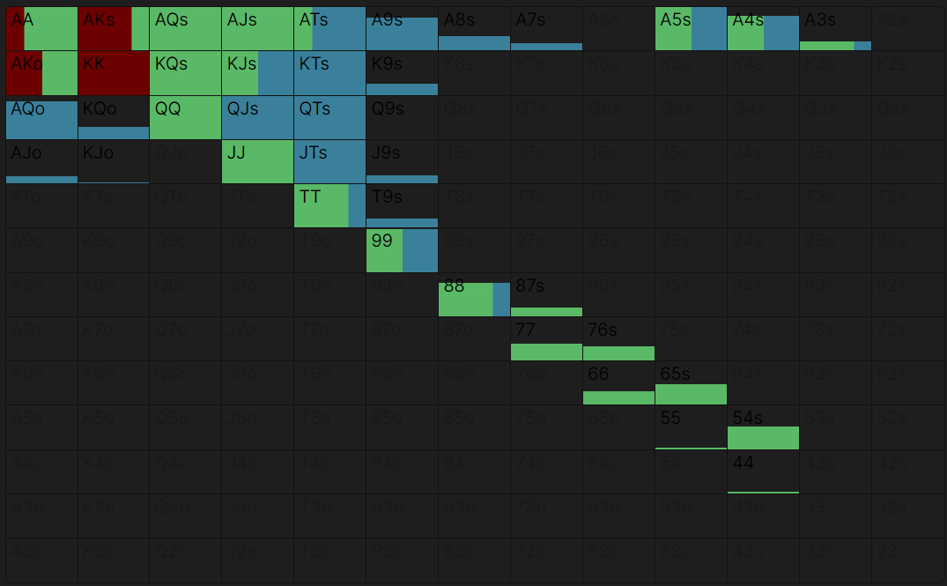

Vs HJ
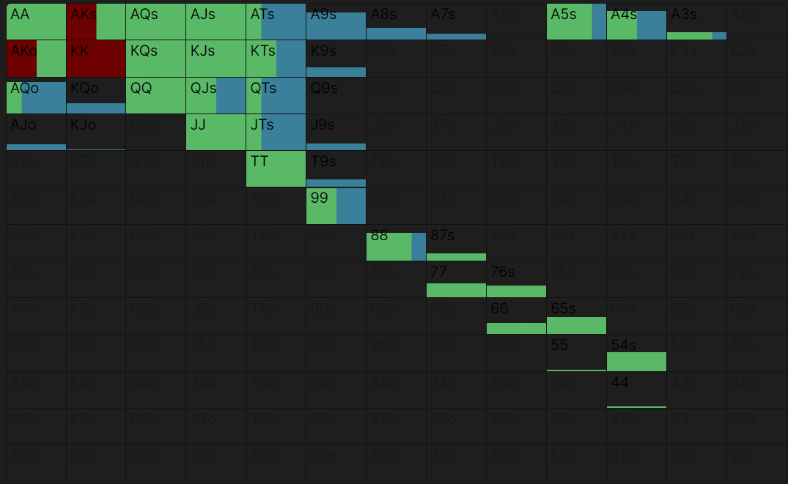

BU

RFI

BU
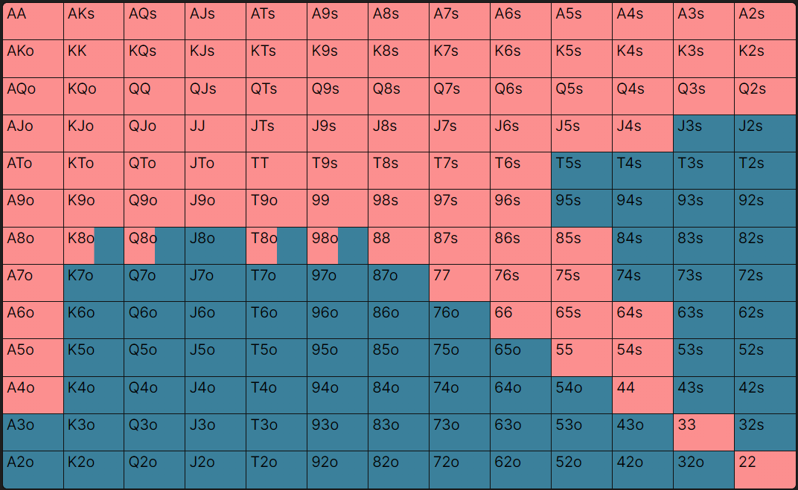

3-Bet

Vs UTG
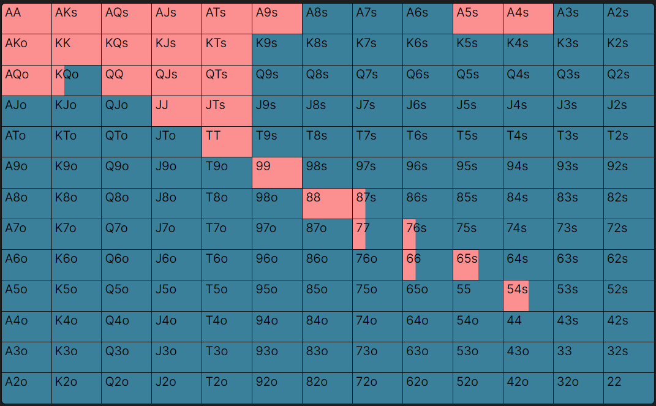

Vs HJ
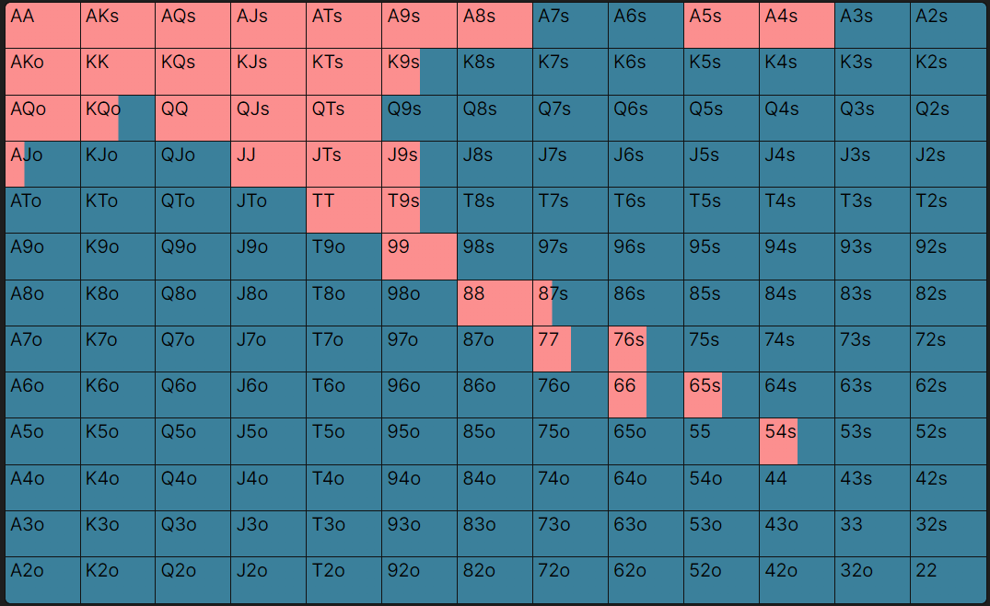

Vs CO
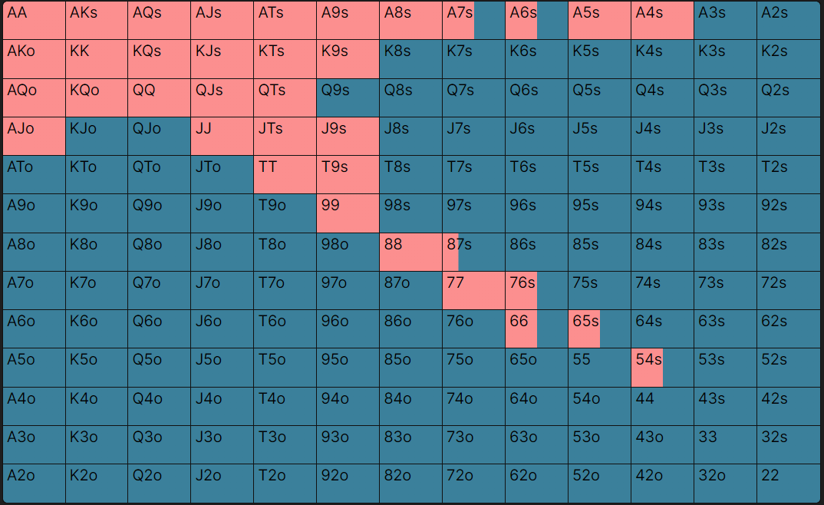

Defend

Vs SB
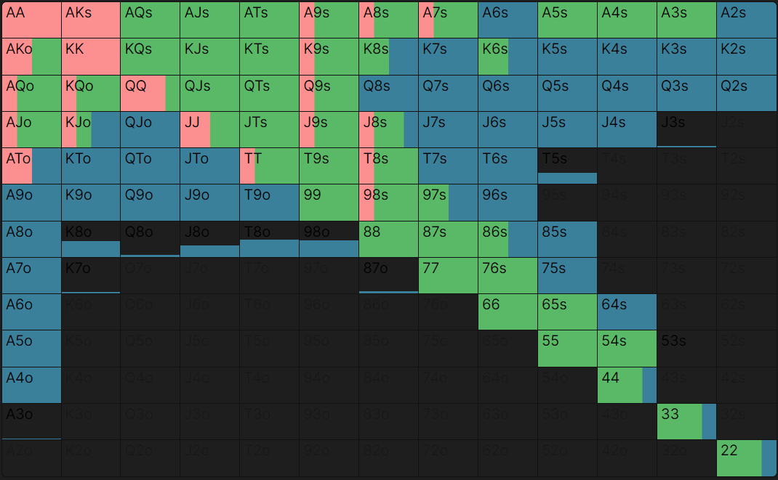

Vs BB
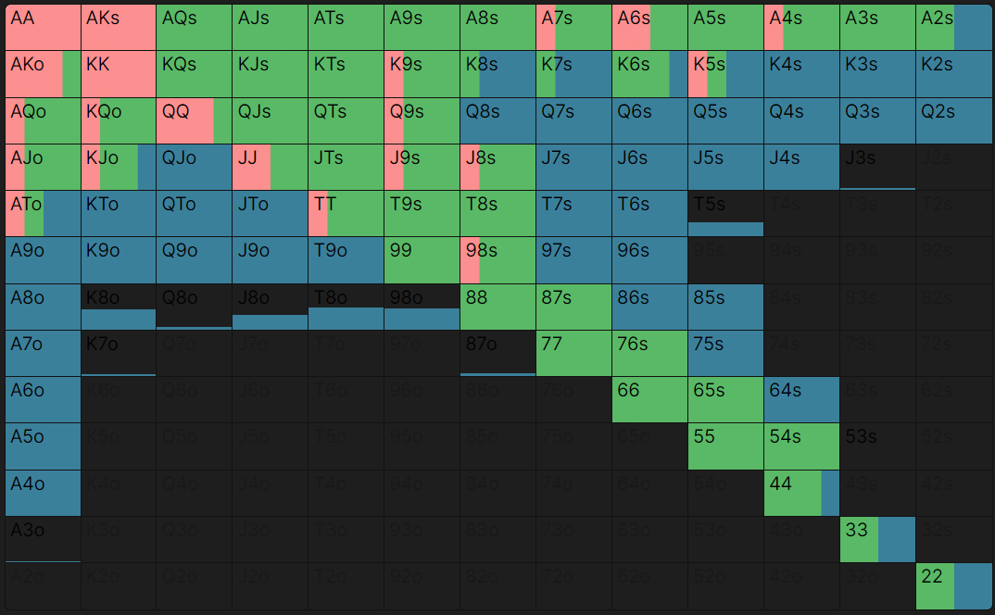

Vs 4-Bet

Vs UTG
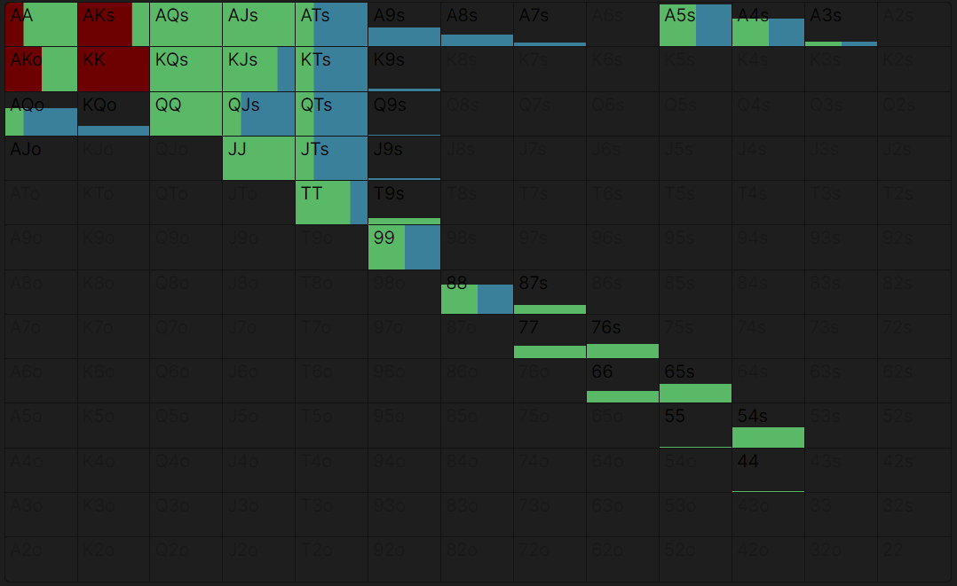

Vs HJ

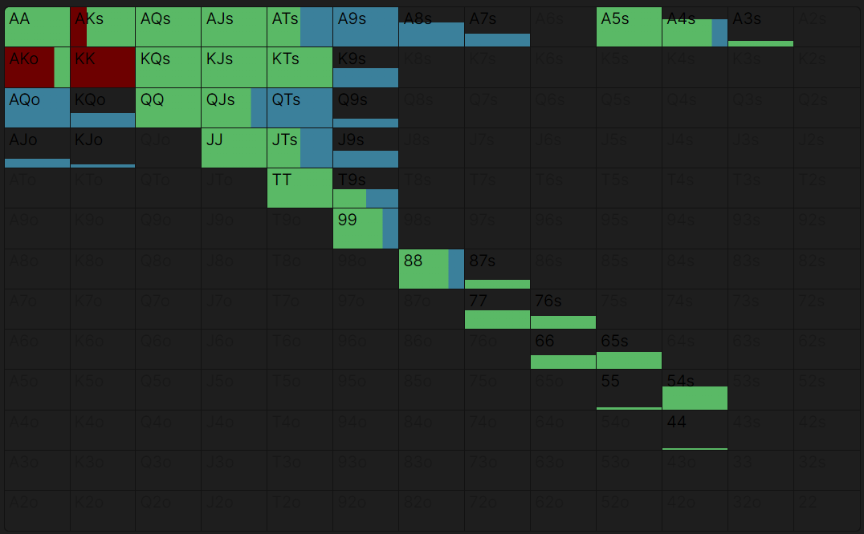

Vs CO
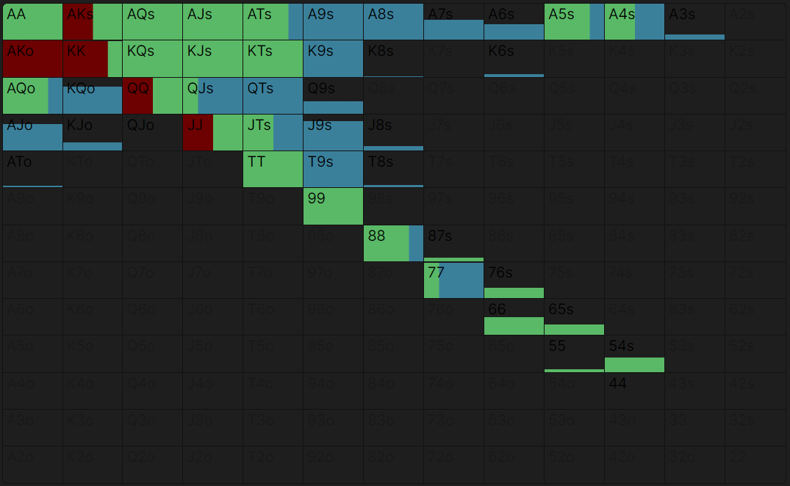

SB

RFI

SB

3-bet

Vs UTG
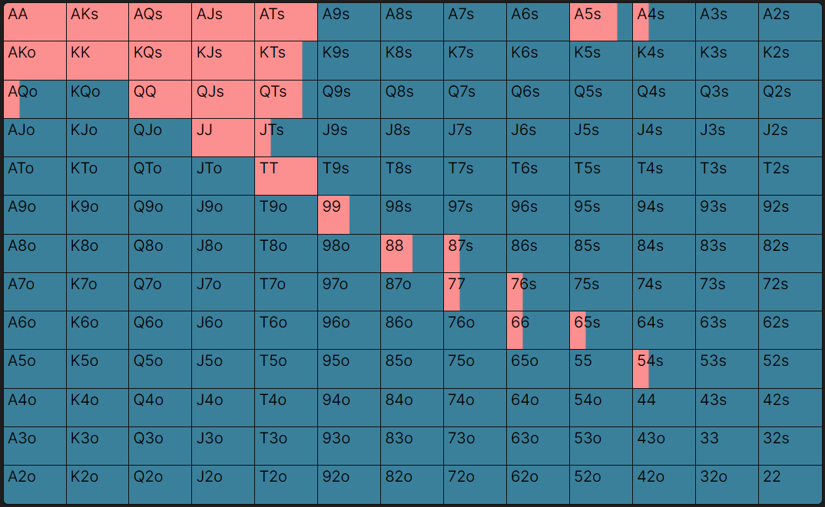

Vs HJ
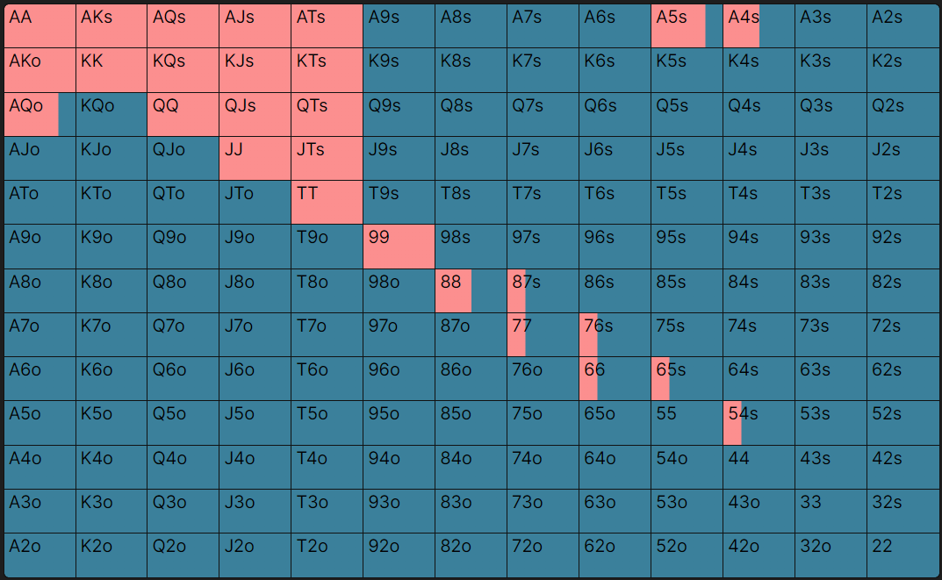

Vs CO
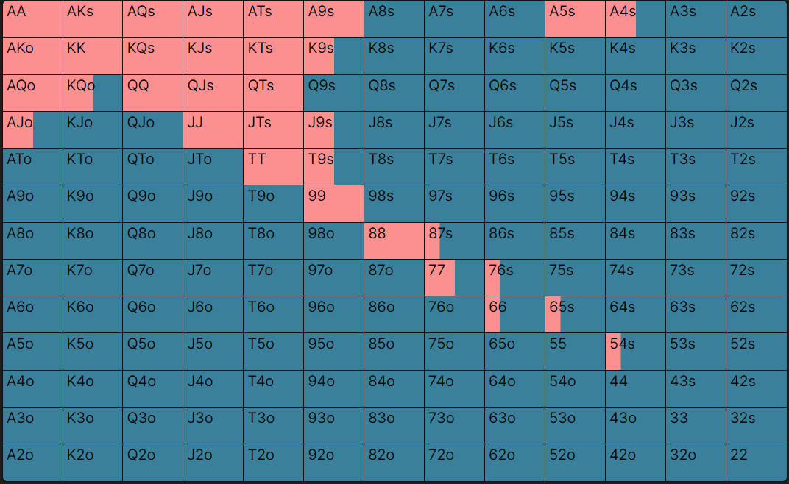

Vs BU
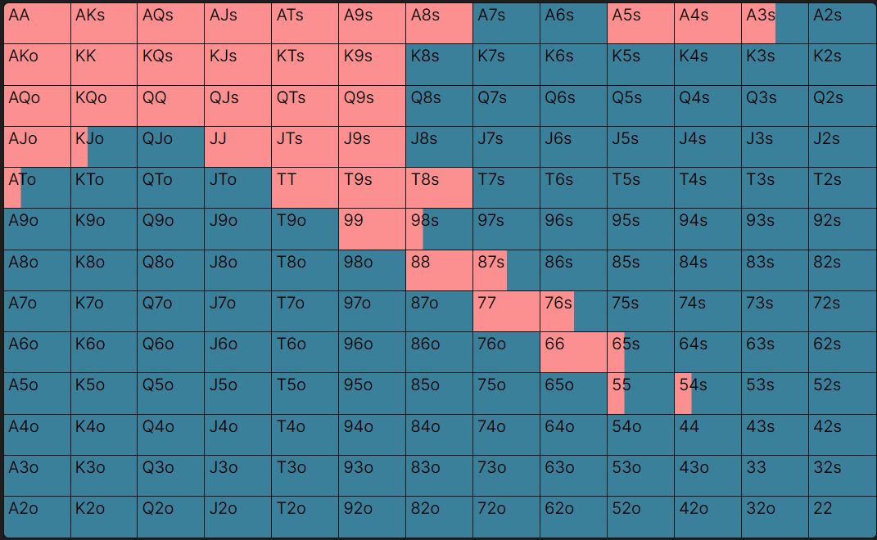

Defend

Vs BB
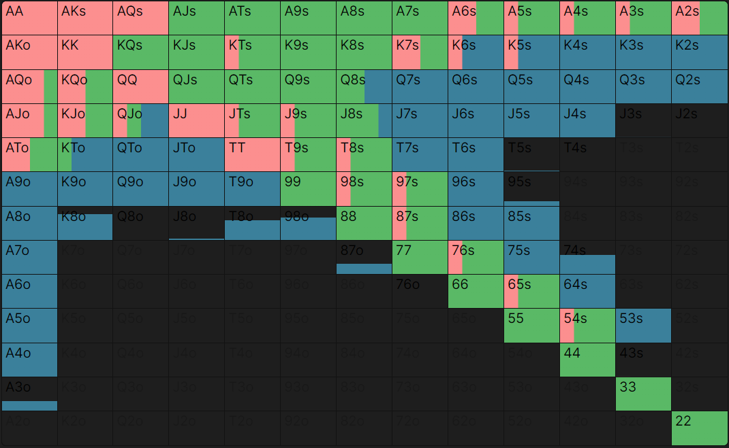

Vs 4-Bet

Vs UTG
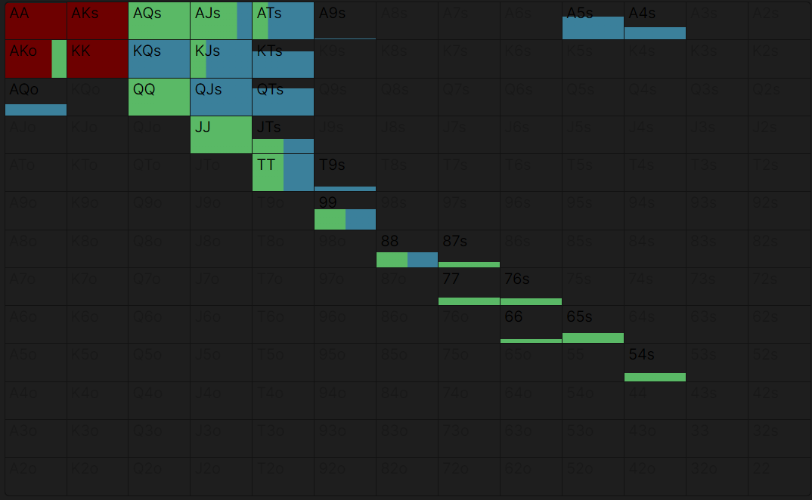

Vs HJ
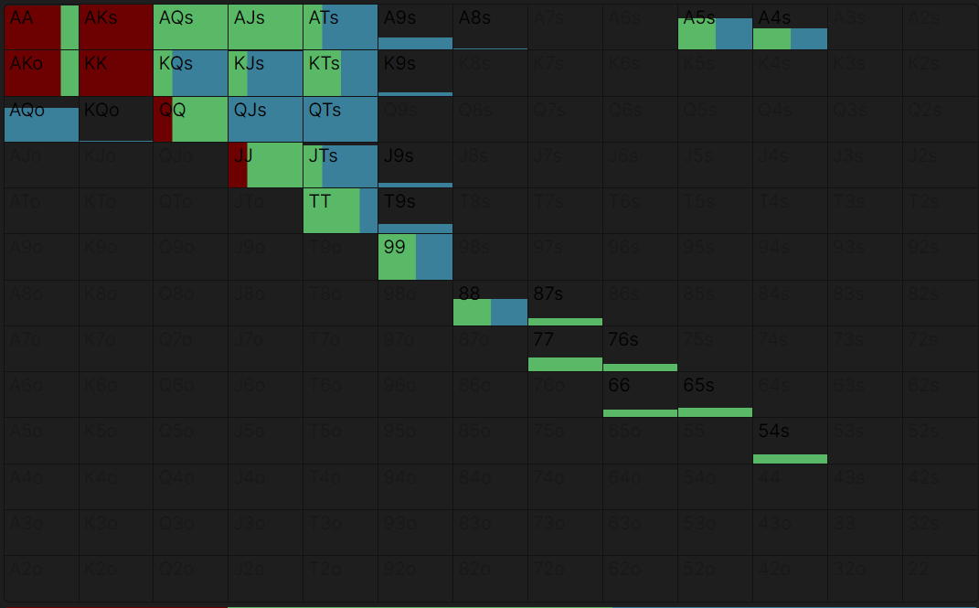

Vs CO
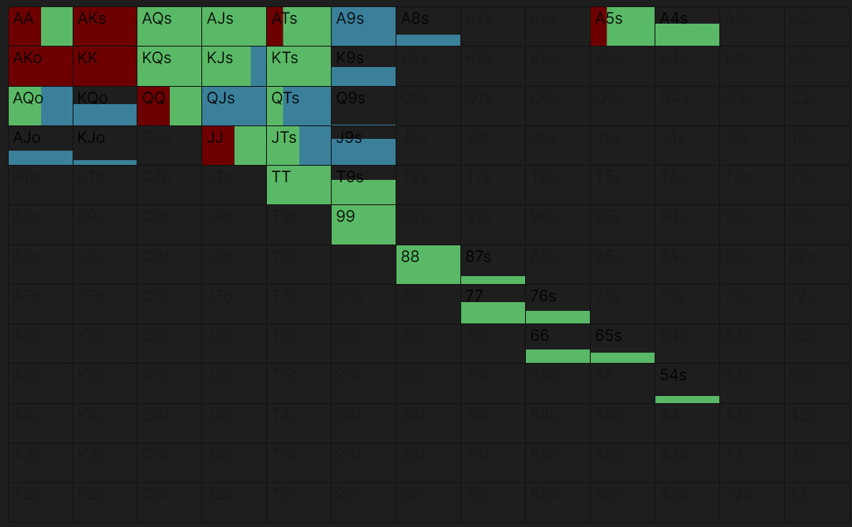

Vs BTN
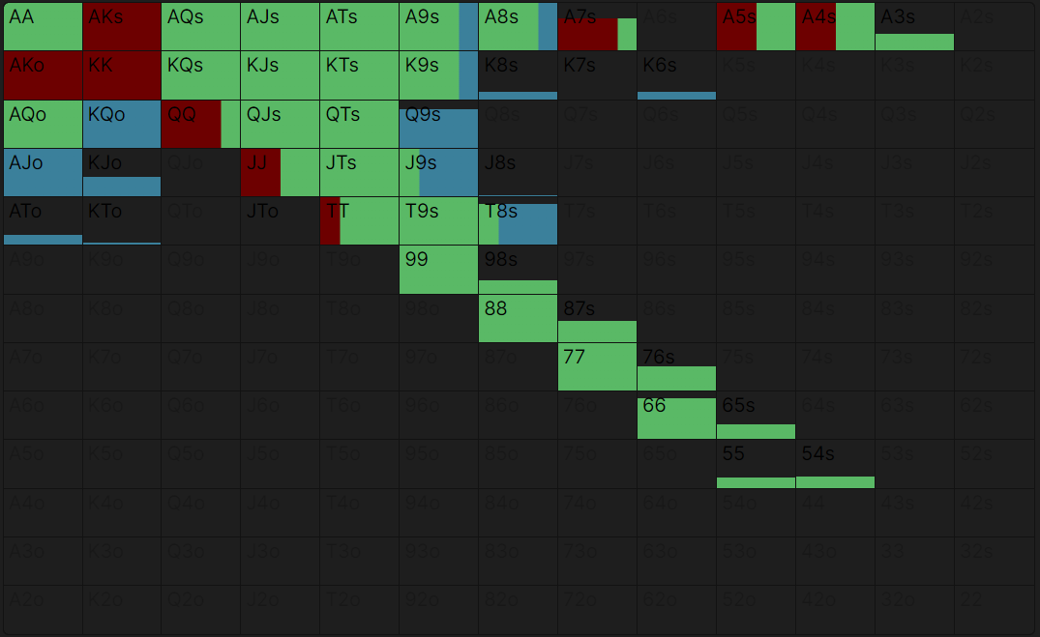

BB

Defend vs RFI

Vs UTG
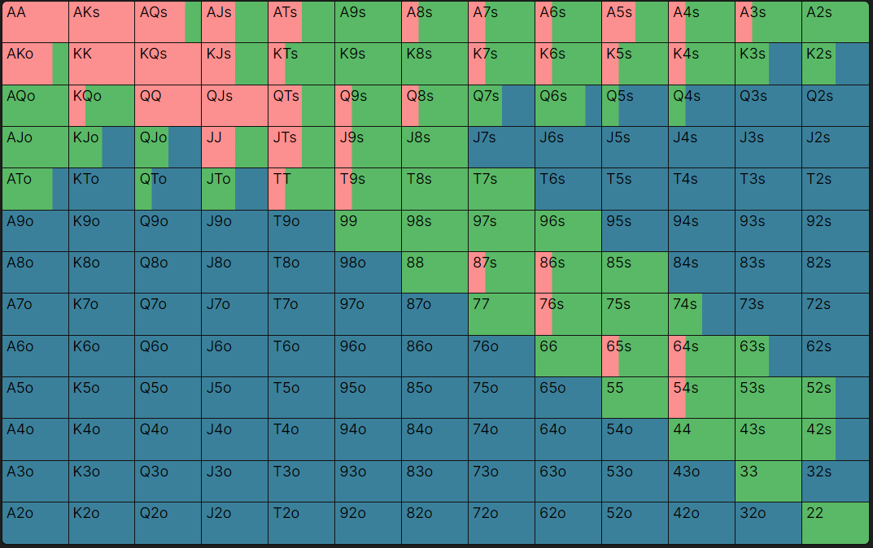

Vs HJ
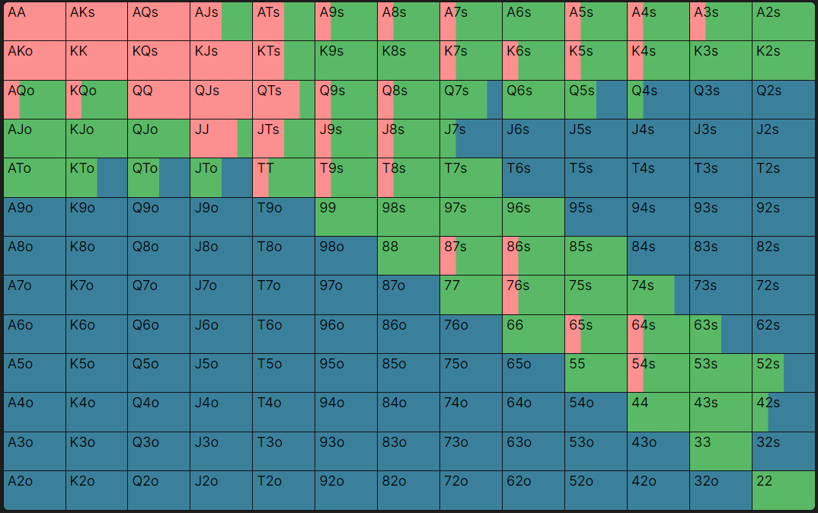

Vs CO
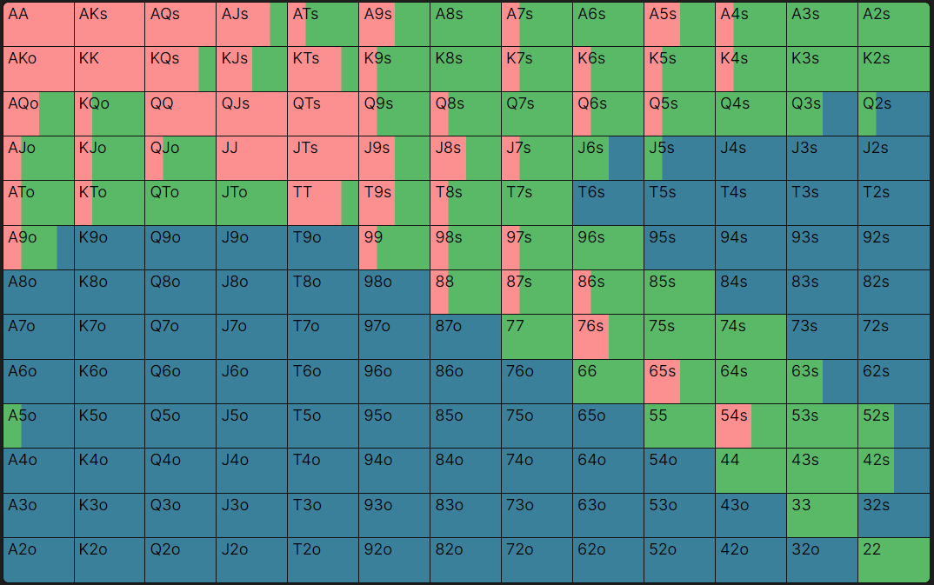

Vs BU
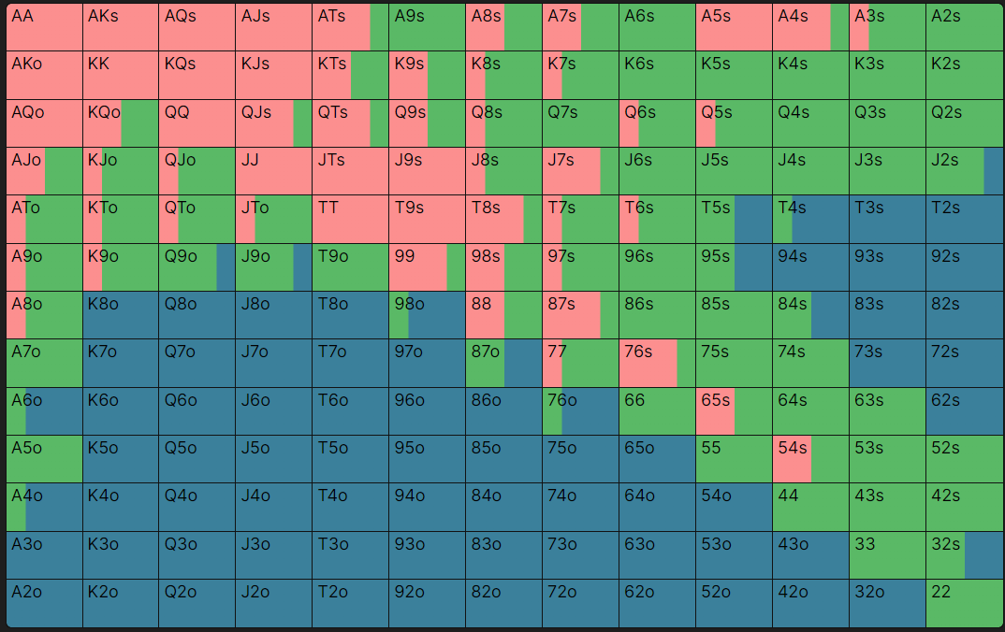

Vs SB
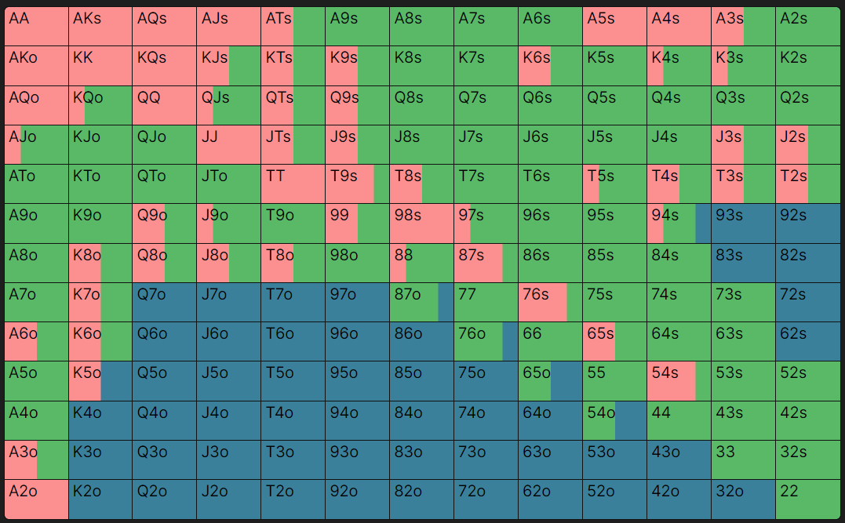

Vs 4-Bet

Vs UTG
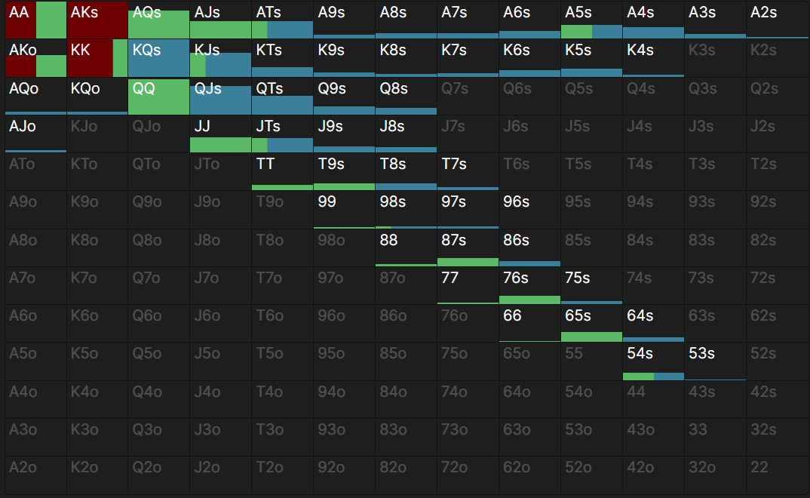

Vs HJ
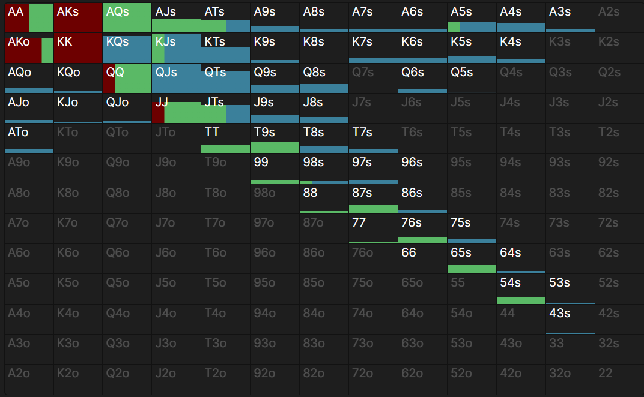

Vs CO
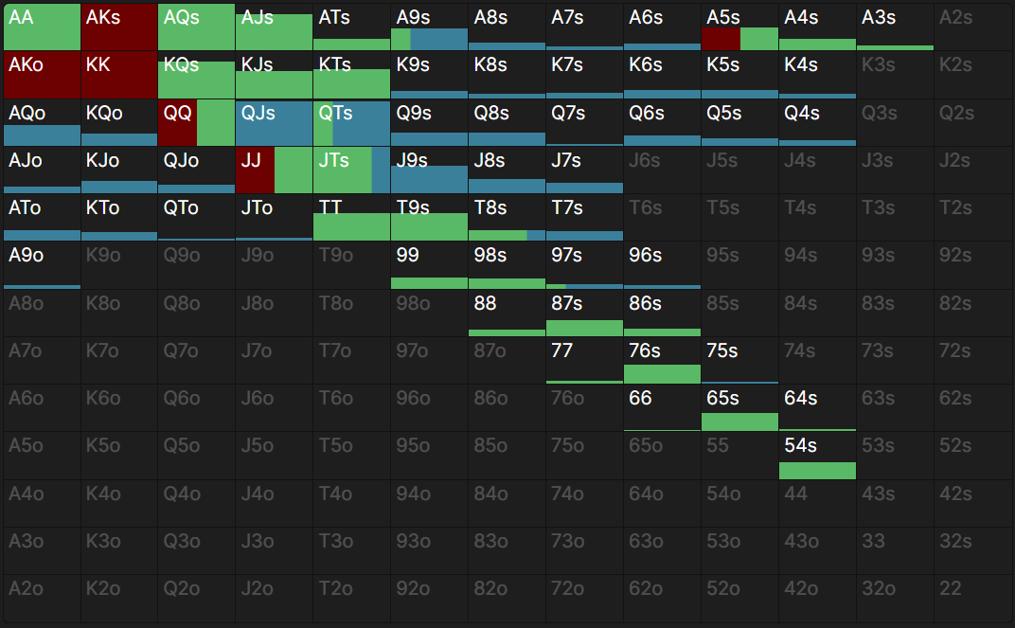

Vs BTN
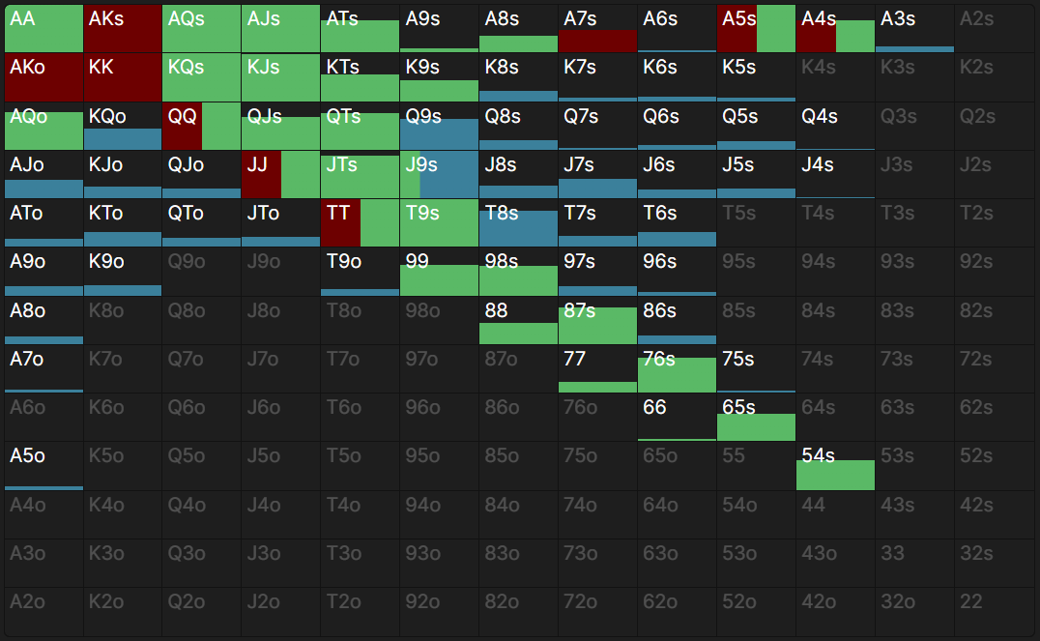

Vs SB
